Ozone Transport Commission
White Paper on Control Measures for Nitrogen Oxides (NOx) Emissions from Two Source Categories
STATIONARY and AREA SOURCES COMMITTEE
8/28/2017

Table of Contents
Purpose 4
Background 5
Good Neighbor provision for the 2015 Ozone National Ambient Air Quality Standards (NAAQS) under the Clean Air Act (CAA) 5
Two Nitrogen Oxides (NOx) Emissions Source Categories 6
Natural Gas Pipeline Compressor Prime Movers 8
Background 8
Emissions Control 10
Opportunities for Further Emissions Reductions 12
Cement Manufacturing 14
Cement Plants in the OTR and CSAPR Update States 14
Background 14
Existing NOx Emissions Control 17
EPA Rules Affecting Cement Plants 18
OTC Cement Kiln Review and Recommendations 19
Recommendations for NOx Emissions Control 19

List of Figures
Figure 1 States within OTR and in CSAPR Update 4
Figure 2 Top Non-EGU Stationary Source Categories of NOx Emissions in OTR States (Panel A) and in CSPAR Update + OTR States (Panel B), excluding EGUs, Airport LTO, and the state of Virginia 7
Figure 3 Pipeline Transportation of Natural Gas NOx Emissions for CSAPRU and OTR States showing facilities emitting ≥50 tons per year 8
Figure 4 Overview of Oil & Gas Pipeline System 10
Figure 5 NOx Emissions from Cement Manufacturing Sector in OTR and CSAPR U region 14
Figure 6 Schematic of a Cement Kiln Operation 15
Figure 7 Components of a Dry Process Precalciner Cement Kiln 16

List of Tables
Table 1 NOx Limits for Pipeline Compressors 10
Table 2 Baseline VOC Emission Estimates for Reciprocating and Centrifugal Compressors^{a,} 12
Table 3 Cost Effectiveness and Cost Burden of SNCR and SCR Systems 18
Table 4 Emission Guidelines for Cement Kilns per 2006 OTC Resolution 19
Table 5 Potential NOx Reduction from Cement Kilns in 19 States Within CSAPR U and OTR, Regardless of Regulations 20

Recommendations on Control Measures for Nitrogen Oxides (NOx) Emissions from Two Source Categories within States in the Ozone Transport Region and the Cross-State Air Pollution Rule Update

Purpose
This report offers recommendations for nitrogen oxides (NOx) emissions reduction from two source categories within the member states of the Ozone Transport Commission (OTC) and those covered under the Cross-State Air Pollution Rule Update (CSAPR U), in partial fulfilment of item 3 of the November 17, 2016 Charge to the OTC’s Stationary and Area Sources (SAS) Committee. That Charge reads as follows:
“Develop and prioritize recommendations and model rules for stationary/area source strategies that states should consider as they develop Good Neighbor state implementation plans (SIPs) that are due in 2018. These recommendations should consider a variety of factors including: sector NOx/VOC emissions, potential emission reductions, cost, and ease of implementation.”
The Report focuses on Natural Gas Pipeline Compressor Prime Movers, and Cement Manufacturing Plants as the NOx source categories, which together account for over 20% of the annual NOx emissions from large non-electric generating unit (EGU) stationary sources within the OTR and CSAPR U states (Fig. 1), based on the United States Environmental Protection Agency’s (EPA) 2014 National Emissions Inventory (NEI) database version 1.
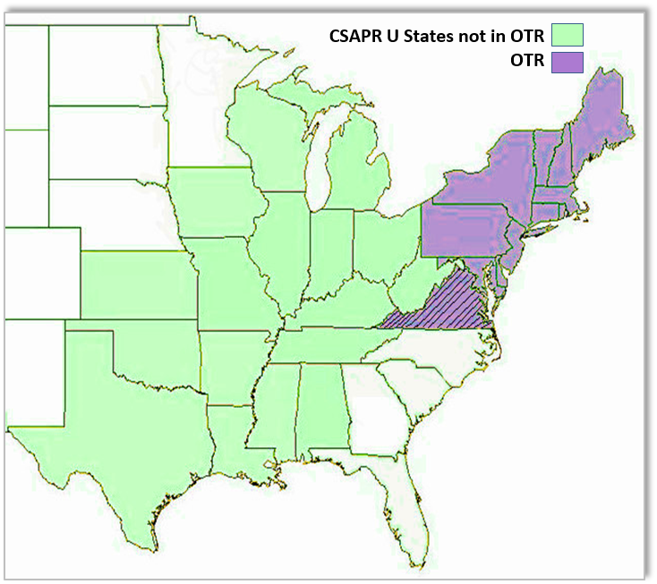
Figure 1 States within OTR and in CSAPR Update

Background

Good Neighbor provision for the 2015 Ozone National Ambient Air Quality Standards (NAAQS) under the Clean Air Act (CAA)
Under CAA Sec. 110(a)(l) and 110(a)(2), each state is required to submit a state implementation plan (SIP) that provides for the implementation, maintenance and enforcement of each primary or secondary NAAQS. Sec. 110(a)(l) also requires each state to make this new SIP submission within 3 years after promulgation of a new or revised NAAQS. This type of SIP submission is commonly referred to as an "infrastructure SIP." The conceptual purpose of an infrastructure SIP submission is to assure that the state's SIP contains the necessary structural requirements for the implementation of the new or revised NAAQS, whether by establishing that the SIP already contains or sufficiently addresses the necessary provisions, or by making a substantive SIP revision to update the SIP. CAA Sec. 110(a)(2)(D)(i)(I) requires each state in its SIP to prohibit emissions that will significantly contribute to nonattainment of a NAAQS, or interfere with maintenance of a NAAQS, in a downwind state. Under section 110(a)(2)(D)(i)(I), each state is required to submit to the EPA new or revised SIPs that "contain adequate provisions - prohibiting, consistent with the provisions of this subchapter, any source or other type of emissions activity within the state from emitting any air pollutant in amounts which will ... contribute significantly to nonattainment in, or interfere with maintenance by, any other state with respect to any such national primary or secondary ambient air quality standard." For purposes of this document, we refer to section 110(a)(2)(D)(i)(I) as the "Good Neighbor Provision" (also shown below and in reference 1) and to SIP revisions addressing this requirement as "Good Neighbor SIPs."
The EPA notes that a consistent framework for addressing transport for certain NAAQS involve a number of basic steps, which have developed in several previous federal rulemakings. These basic steps include: (1) identifying downwind air quality problems, (2) identifying upwind states that contribute enough to those downwind air quality problems to warrant further review and analysis, (3) identifying the emissions reductions necessary to prevent an identified upwind state from contributing significantly to those downwind air quality problems and (4) adoption of permanent and enforceable measures needed to achieve those emissions reductions. Efforts to address ozone transport by the EPA and states under the "Good Neighbor" Provision have focused on reductions of NOx as the precursor pollutant for which emissions in upwind states have the greatest impacts on transported ozone.

Two Nitrogen Oxides (NOx) Emissions Source Categories
OTC and state members recommend control measures for natural gas pipeline systems and cement manufacturing plants. This recommendation is a result of emissions data and sector analysis described below.
To identify the top NOx emitters in the OTR and in CSAPR U states, OTC members reviewed the 2014 NEI v1 using the 5 digit North American Industry Classification System (NAICS) codes associated with emitting facilities. The 2014 NEI data was utilized for all source categories in an attempt to maintain a consistent evaluation basis. However, note that there appears to be some discrepancy with state-to-state reporting of emissions related to some oil and gas industry emissions with regards to how those emissions are categorized. Evaluation of these discrepancies are beyond the scope of this review process. The noted discrepancies do not impact the fact that subcategories within the oil and gas industry rank as some of the highest overall categories reviewed in this effort.
2014 NEI v1 data revealed two of the highest NOx sources as pipeline transportation of natural gas and cement manufacturing. These two categories are among the top five emitting source categories, when Electric Power Generation & Airport Landing and Takeoff were excluded. The electric power generation category was omitted from this analysis because emission controls on large EGUs (≥25 megawatt (MW)) capacity that report to the United States Environmental Protection Agency’s (EPA’s) Clean Air Markets Division (CAMD) are being addressed in separate reports as part of SAS charge #1 and #2. Recommendations on emission reductions from smaller EGUs (<25 MW capacity) and other units that operate on High Electric Demand Days (HEDD) are being addressed in SAS charge #4.
Figure 2 is based on the 2014 NEI v1 and shows the top 10 NOx emitting categories of the OTR states and the top 15 NOx emitting categories for the OTR and CSAPR U states (excluding EGUs and airport landing-takeoff operations (LTOs)). According to the 2014 NEIv1, Pipeline Transportation of Natural Gas was the top NOx emitter in CSAPR U states not in the OTR releasing 174,645 tons per year (tpy). This category ranked number 5 in OTR states accounting for 7,853 tpy. Cement Manufacturing Plants were the second highest NOx emitters in both CSAPR U states not in the OTR and in OTR with 69,138 tpy and 13,151 tpy respectively. One issue not identified in the NEI is that the 2014 data reported directly to the State of Pennsylvania (PA) from the regulated community indicate that NOx emissions from PA non-conventional oil/gas drilling and well completion activity are higher than the total OTR pipeline compressor NOx emissions represented in the 2014 NEI. The NOx emissions data seems to be consistent with the amount of well drilling and development occurring in the PA Marcellus shale region. The part of Virginia outside the OTR was excluded from our review.
In this report we discuss the NOx emission profiles of natural gas pipeline systems focusing on compressors, and cement manufacturing plants and offer recommendations of potential emission control measures.

Figure 2 Top Non-EGU Stationary Source Categories of NOx Emissions in OTR States (Panel A) and in CSPAR Update + OTR States (Panel B), excluding EGUs, Airport LTO, and the state of Virginia

Natural Gas Pipeline Compressor Prime Movers

Background
The U.S. natural gas pipeline grid is an integrated transmission and distribution network that transports natural gas to and from numerous locations in the contiguous 48 States. This grid consists of 305,000 miles of interstate and intrastate transmission pipelines in more than 210 pipeline systems, which include 1,400 compressor stations that maintain pressure on the network and assure continuous forward movement of supplies through more than 11,000 delivery points, 5,000 receipt points, and 1,400 interconnection points. The pipeline grid has 24 hubs or market centers that provide additional interconnections, and 400 underground natural gas storage facilities (Fig. 3).
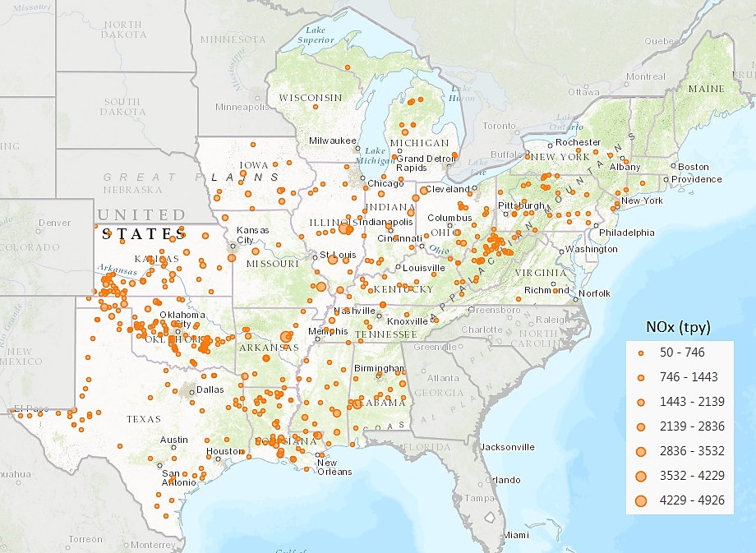
Figure 3 Pipeline Transportation of Natural Gas NOx Emissions for CSAPRU and OTR States showing facilities emitting ≥50 tons per year
Pipeline compressors are important components of natural gas transport system and are used to convey the fuel through pipelines over long distances for distribution to end-use consumers or rerouting into storage areas during periods of low demand.
The number of compressor station facilities located along a natural gas pipeline (one every 40-100 miles), and the amount of pressure they generate (200-1,500 pounds per square inch (psi), vary depending on:
- the topography of the area across which the pipelines traverse (those on hilly terrain require more frequent pressure increases than on flat terrain)
- the pipeline length and diameter
- the product being moved
- the design characteristics of the compressor or pump
- “Supply and demand can also be a factor at times in the level of compression required for the flow of the natural gas.”
The compressor unit is the primary equipment “which actually compresses the gas”. “Some compressor stations may have multiple compressor units depending on the needs of the pipeline.” A prime mover provides power to the compressor, which is generally one of the three following types:
- Turbines with Centrifugal Compressors – These units use turbines for compression fueled by natural gas from the pipeline itself.
- Electric Motors with Centrifugal Compressors – These are also centrifugal compressors but are powered by high voltage electric motors.
- Reciprocating Engine with Reciprocating Compressor – These compressors use large engines “to crank reciprocating pistons located within cylindrical cases on the side of the unit” to compress the gas, and are fueled by natural gas.
In 2010, the OTC identified natural gas pipeline compressor prime movers as a potential emission source category within the OTR and developed a white paper for control strategies and recommended potential Commission action, e.g., adopt a model rule to achieve NOx emissions reductions from this emission source.
Within the OTR, natural gas pipeline compressor prime movers fueled by natural gas are used in several phases of natural gas supply:
1) gathering the natural gas from the well field and transporting it to the main transportation pipeline system;
2) moving natural gas through the main pipeline system to distribution points and end users; and
3) injecting and extracting natural gas from gas storage facilities, (Fig. 4).
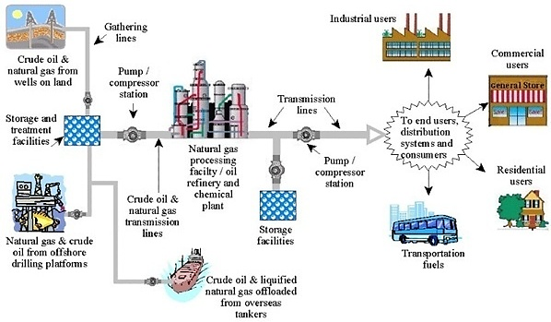
Figure 4 Overview of Oil & Gas Pipeline System
These natural gas pipeline compressor prime movers which include 2-stroke and 4-stroke lean-burn internal combustion (IC) reciprocating engines, 4-stroke rich-burn IC reciprocating engines, and combustion turbines, are a significant source of NOx emissions year-round. The fossil-fuel compressor prime movers have become greater contributors to overall ozone season NOx emissions, as their operation is increased to meet the demand related to natural gas consumption by gas-fueled electric generating units during the ozone season.
According to the 2014 NEI data, nine OTR states (CT, MA, MD, ME, NJ, NY, PA, RI, and VA) have large natural gas compressor facilities with three of them (MD, NY, PA) containing several well field compressors, and two (PA, NY) having natural gas underground storage facilities (See attached Spreadsheet-Appendix). These include:
- More than 900 reciprocating engine prime movers with ratings up to 7,500HP
- More than 150 combustion turbine prime movers with rating up to 37,000HP

Emissions Control
In partial fulfillment of item 3 of the November 17, 2016 Charge to the OTC’s Stationary and Area Sources (SAS) Committee, the OTC Control Measures Workgroup has developed an updated model rule that can be found in a separate document titled “Proposed 2017 OTC Model Rule for Control of NOx Emissions from Natural Gas Pipeline Compressor Fuel-Fired Prime Movers”, August, 2017.
Our recommendations for NOx limits for pipeline compressors are summarized in Table 1 and elaborated in the accompanying model rule.
Table 1 NOx Limits for Pipeline Compressors
- Two-Stroke Lean Burn ICE
Nameplate Rating (HP) | NOx Rate (g/BHP-hr)  or (% Reduction)
200 - 499 | 2.0 (80%)
500 - 1999 | 1.5 (80%)
≥2000 | 1.5 (90%)
- Four-Stroke Lean Burn ICE
Nameplate Rating (HP) | NOx Rate (g/BHP-hr)  or (%Reduction)
200 - 499 | 1.5 (90%)
500 - 1999 | 1.5 (90%)
≥2000 | 1.5 (90%)
- Four-Stroke Rich Burn ICE
Nameplate Rating (HP) | NOx Rate (g/BHP-hr)  or (%Reduction)
200 - 499 | 1.5 (90%)
500 - 1999 | 1.5 (90%)
≥2000 | 1.0 (90%)
- Combustion Turbines*
Nameplate Rating (HP)  (MW) | NOx Rate (ppmvd @ 15% O₂)
≤2000 (1.5) | 150.0 (6.0 lb/MWh)
2000 – 4999 (1.5-3.7) | 50.0 (2.0 lb/MWh)
≥5000 (3.7) | 25.0 (1.0 lb/MWh)
*Combustion Turbine NOx rates are from 40 CFR 60 Subpart KKKK Table 1.
It is also assumed that new facilities must also comply with applicable Standards of Performance for New Source Performance Standards (NSPS) for reciprocating combustion engines (RICE), e.g., non-emergency RICE at major sources and that new and existing non-emergency RICE must also comply with applicable National Emission Standards for Hazardous Air Pollutants (NESHAPS). New combustion turbine compressor prime movers would also be required to meet applicable NSPS emission limitations.

Opportunities for Further Emissions Reductions
Control of Volatile Organic Compounds (VOCs) from the oil and gas sector compressor stations.
- Gathering & boosting compressor stations (SIC 1311) for gathering lines and transmission line compressor stations (SIC 4922) in some cases need additional equipment to filter and remove liquids from the gas stream. Glycol dehydrators remove water, and Amine units remove CO₂ and H₂S, from the gas stream.
- Midstream, gathering and boosting compressor stations receive gas from the surrounding gathering field. The gas can enter the facility at various pressures depending on the gas gathering pipeline(s) pressure(s). The gas is routed to separators (or slug catchers) to knockout heavier hydrocarbon liquids and water which are routed to either pressurized condensate stabilizers or to atmospheric storage tanks. Those liquids can escape to the atmosphere. In addition, tanks on compressor station sites often leak VOCs into the atmosphere.
- Since VOCs are also ozone precursors, one potential area for future analysis could be the quantification and impact of VOC emissions from oil and gas sector compressor stations.
The Workgroup suggests future work with maintenance requirements provided in NSPS OOOOa as a suggested control measure as defined below to address the baseline VOC emissions from different compressor type shown in Table 2.

Table 2 Baseline VOC Emission Estimates for Reciprocating and Centrifugal Compressors^{a,}
Industry Segment/Compressor Type | Baseline VOC Emission Estimates (tpy)
Reciprocating Compressors
Gathering and Boosting Stations | 3.42
Processing | 6.12
Centrifugal Compressors (Wet seals)
Processing | 19.1
Centrifugal Compressors (Dry seals)
Processing | 2.4
ª For centrifugal compressors, it was assumed that 75% of the natural gas that is compressed is pipeline quality gas and 25% of the natural gas is production quality.
“Centrifugal compressors - Centrifugal compressors are equipped with either wet seal systems, or dry seal systems.
  - Compressors with wet seals use oil as a barrier to keep gas from escaping. The gas that becomes absorbed in the oil is continuously vented, along with the methane, VOCs and air toxics it contains. The final rule requires a 95 percent reduction of methane and VOC emissions from compressors with wet seal systems. This can be accomplished through flaring, or by routing captured gas back to a process.
  - Compressors using dry seal systems, which have low methane and VOC emissions, are not covered by the final rule. EPA encourages owners/operators to use compressors with dry seal systems where possible.
Reciprocating compressors – The final rule requires the replacement of rod packing systems in reciprocating compressors. Over time, these packing systems can wear, leaking methane and VOCs. The rule provides two options for replacing rod packing:
  - On or before every 26,000 hours of operation (operating hours must be monitored and documented); or
  - Every 36 months (monitoring and documentation of operating hours not required).
As an alternative to changing rod packing, operators may opt to route emissions from the rod packing via a closed vent system under negative pressure to be reused or recycled by a process or piece of equipment.”

Cement Manufacturing

Cement Plants in the OTR and CSAPR Update States
The workgroup reviewed the 2014 NEI v1 database using the 5 digit NAICS for Cement Manufacturing which showed this sector to be a significant source of NOx accounting for more than 82,000 tons per year (tpy) from facilities within the OTR and CSAPR Update states (Fig. 5)

Figure 5 NOx Emissions from Cement Manufacturing Sector in OTR and CSAPR U region
The OTR states that do not have cement kiln operations are: CT, DC, DE, MA, NH, NJ, RI, and VT. The CSAPR U states outside the OTR that do not have cement kiln operations are: LA, MS, and WI. For the states that do have cement kilns, some do not have a regulation limit in their state rules while others have a NOx emission limit between 1.7 – 6.8 lbs/ton clinker (30 day average) depending on the type of kilns. OTC state regulations for cement kilns noting the specific types of kilns are found in Appendix A. Depending on the type of kiln, i.e. Long Dry, Long Wet, Pre-heater (PH) and Pre-calciner (PC), the NOx emission limits in the OTR for kilns whether new or older than 50 years range from 1.52 – 3.88 lbs/ton clinker per 30 day average. In 2010 EPA finalized the Cement NSPS (40 CFR Part 60, Subpart F) which requires PH/PC kilns to meet a limit of 1.5 lb NOx/ton clinker. It is assumed SNCR will be installed on all new kilns to control NOx, and Continuous Emissions Monitoring (CEM) will be installed for compliance with EPA requirements. Appendix A has a table of Uncontrolled NOx Emission Data from the EPA 2000 Alternative Control Techniques (ACT) which shows the average uncontrolled NOx rate in the range of 1.7 - 6.2 lbs/ton clinker per 30 day average.

Background
“Portland cement manufacturing is an “energy‐intensive process that grinds and heats a mixture of raw materials such as limestone, clay, sand and iron ore in a rotary kiln” into a product called clinker which “is cooled, ground and then mixed with a small amount of gypsum to produce cement” (Fig. 6).
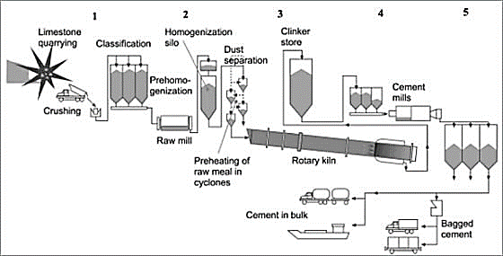
Figure 6 Schematic of a Cement Kiln Operation
“The main source of air toxics emissions from a Portland cement plant is the kiln.” Emissions of a variety of pollutants originate in the kiln from “the burning of fuels and heating of raw feed materials”, and “from the grinding, cooling, and materials handling steps in the manufacturing process””.
“There are essentially two general types of cement kilns, wet and dry:
Wet process kilns: The original rotary cement kilns were called 'wet process' kilns since the raw meal (the mixture of minerals whose composition varies with the desired final product) used was in the form of a slurry with ~40% water at ambient temperature. Evaporating this water to dry out the slurry is an energy-intensive process and “various developments of the wet process (such as the 'filter press') were aimed at reducing the water content of the raw meal”. The wet process still continues today because many raw materials are suited to blending a slurry.
Dry process kilns: The basic dry process system consists of the kiln and a suspension preheater. Raw materials such as limestone and shale are ground finely and blended to produce the raw meal which is fed in at the top of the “suspension preheater” tower. This tower has a series of cyclones through which fast-moving hot gases from the kiln and, often, hot air from the clinker cooler are blown to keep the meal powder suspended in air until it reaches the same temperature as the gas. So the raw meal is heated before it enters the kiln.”
““The dry process is much more thermally efficient than the wet process” because the meal is a dry powder with little or no water to be evaporated, and the heat transfer from the hot gases to the raw meal is efficient because of the very high surface area to-size ratio of meal particles and the large temperature differential between the hot gas and the cooler meal. Typically, 30-40% of the meal is de-carbonated before entering the kiln.
Most new cement plants are of the 'dry process' type and use 'precalciner' kilns which operate on a similar principle to that of preheater system but with the major addition of another burner called precalciner (Fig. 7). With this additional heat, about 85-95% of the meal is de-carbonated before it enters the kiln. “Whenever economically feasible a wet process kiln can be converted to a state-of-the art dry process production facility” that includes a multi-stage preheater with or without a precalciner.”
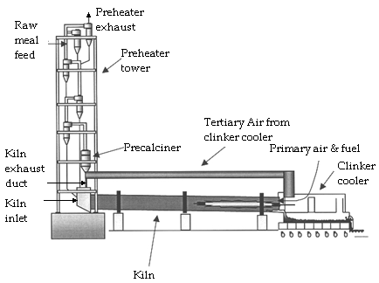
Figure 7 Components of a Dry Process Precalciner Cement Kiln
“Thermal NOx is the primary form of NOx emissions in cement manufacturing because of the high temperatures and oxidizing conditions required for fuel combustion and clinker formation. The NOx controls employed in cement plants include LNBs, mid-kiln system firing, staged combustion in the calciner (SCC), SNCR and SCR, as discussed below.

Existing NOx Emissions Control
EPA’s 2007 ACT Update on NOx Emissions from Cement Kilns addresses the practices of and NOx controls for new cement kilns (i.e. only PH/PC kilns since these are the only kind expected to be built in the future, instead of wet and long dry kilns). This Cement ACT focuses specifically on staged combustion in the calciner (SCC), selective noncatalytic reduction (SNCR), and selective catalytic reduction (SCR) as processes to control NOx emissions. Regarding uncontrolled NOx emissions, the ACT recommends consideration of the following components as a standard operating practice which is now an integral part of all new PH/PC kiln systems:
- Combustion zone control of temperature and excess air through their continuous monitoring
- Feed mix composition
- Kiln fuel type
- Increased thermal efficiency
- Staged combustion in kiln
- Efficient cooler control
- Expert control systems
- Low NOx burners in the kiln.
In addition to the process and combustion controls listed, post combustion SNCR or SCR can be considered. Both the SCR and SNCR Systems vary widely in their cost effectiveness displaying a median of $1,800 and $1,200 respectively per ton of NOx reduced (Table 3). The median cost of a ton of clinker for SCR systems is twice that for SNCR systems (Table 3).
Table 3 Cost Effectiveness and Cost Burden of SNCR and SCR Systems
Measure of Cost | SNCR System | SCR System
Cost Effectiveness ($/t NOx)
Range | 330 to 5,200 | 480 to 22,000
Mean | 1,700 | 4,200
Median | 1,200 | 1,800
Cost Burden ($/t of clinker)
Range | 0.40 to 2.50 | 0.60 to 9.10
Mean | 1 | 2.5
Median | 0.9 | 1.8
Since the Cement ACT in 2007, EPA has regulated cement plants under CAA 111(d) and 129. Through the “Cement Manufacturing Enforcement Initiative” beginning in 2008 and continuing today, EPA has pursued an integrated compliance and enforcement strategy to address CAA New Source Review compliance issues at the nation's cement manufacturing facilities. Various legal settlements have resulted in the reduction of various pollutants, including NOx, from cement plants around the US. Appendix A lists the facilities and date of EPA enforcement settlements.

EPA Rules Affecting Cement Plants
- All cement facilities are subject to the Portland Cement NESHAP (40 CFR 63 subpart LLL) and NSPS (40 CFR 60 subpart F). Amended and Final in September 2010.
- Cement kilns that burn hazardous waste are subject to the Hazardous Waste Combustor NESHAP (40 CFR 63 subpart LLL).
- Cement kilns that burn non-hazardous solid wastes as defined in the upcoming solid waste definition rule will be subject to the Commercial and Industrial Solid Waste Incinerator Units (CISWI) rule (40 CFR 60 subparts CCCC and DDDD) 2011.
The final NSPS amendment (EPA NSPS 40 CFR Part 60, Subpart F) reduces emission limits for NOx, sulfur dioxide (SO₂), and particulate matter (PM) from new kilns constructed or modified June 16, 2008, and requires CEM for each pollutant. All new cement kilns will be PH/PC kilns with SNCR to meet a limit of 1.5 lb NOx/ton clinker.
The final NESHAP amendments (EPA NESHAP 40 CFR 63 subpart LLL) require numerical emissions limits for various pollutants (except NOx) for all existing and new sources. NOx control was not a part of the NESHAP for existing units but system upgrades that are likely to have multi-pollutant reductions.
In August of 2016 EPA prepared a report to support the CSAPR U effort and evaluate the reduction of transported NOx with controls on EGUs and Non-EGUs, using 2011 as the base year with a 2017 future base year. This Report outlines various control technologies that can be applied to cement kilns such as SNCR, Biosolid Injection Technology (BSI) and mid-kiln firing (MKF). The EPA estimates NOx reductions to be gained from cement manufacturing (from an uncontrolled level) to be about 30% at a cost of $73 - $1,255 per ton of NOx removed (See Appendix A). Therefore EPA is advocating that NOx reductions from the cement industry are economically feasible.

OTC Cement Kiln Review and Recommendations
In its 2007 Final Technical Support Document (TSD) on cement kilns, the OTC made a recommendation for a NOx emission rate of 1.52 - 3.88 lbs NOx/ton of clinker produced for the four types of kilns. In 2006, the OTC Commissioners recommended that “OTC member states pursue, as necessary and appropriate, state-specific rulemakings or other implementation methods to establish emission reduction percentages, emission rates or technologies that are consistent with the guidelines” shown below in Table 3 which has been adapted from the TSD. “The guidelines were presented in terms of both an emission rate (lbs/ton of clinker by kiln type) as well as a percent reduction from uncontrolled levels.”
Table 4 Emission Guidelines for Cement Kilns per 2006 OTC Resolution
Kiln Type | Emission Rate  (lbs NOx/ton of clinker produced) | % Reduction from Uncontrolled
Wet Kiln | 3.88 | 60
Long Dry Kiln | 3.44 | 60
(Dry) Preheater Kiln | 2.36 | 60
(Dry) Precalciner Kiln | 1.52 | 60

Recommendations for NOx Emissions Control
Based on the control costs of the SCR and SNCR Systems, and the reduction benefits afforded by various types of kilns, and following the ACT guidelines and Cement NSPS, the workgroup offers the following recommendations to control NOx emissions from cement kilns, where applicable, for all states:
- Install low NOx burners on all kilns
- Modify each kiln to implement mid-kiln firing
- Install post-combustion SNCR
- Convert and retrofit a wet process cement kiln to the more efficient dry cement manufacturing process.
For effective reduction in NOx and ozone levels across the region, the NOx emission limits from the cement manufacturing sector, particularly from those plants employing wet kilns and dry kilns without a precalciner, must be made more stringent for all states.
We recommend that states outside of the OTR covered by CSAPR U implement NOx rates consistent with the 02/28/2007 “Identification and Evaluation of Candidate Control Measures Final Technical Support Document”. Additionally, and coincidental to the EPA ACT, modifying or replacing all wet kilns to modern technology should be considered feasible. In 2017 all OTR States with cement kilns have regulations meeting the proposed rates. All CSAPR U States should adopt the same, which will result in reductions in transported NOx to the OTR.
The emission benefits from the four types of kilns can be estimated from the NEI 2014 v1 database for Cement Manufacturing using SCC Level 3 Code. According to the database, there are 57 plants within the CSAPR U and OTR States, with 82 kiln units operating in 2014; of which 13 are coded in the database as wet kilns, 34 as long dry kilns, 6 as pre-heater kilns and 29 as PH/PC. See Appendix A for the complete list by State. It can also be assumed that cement plants operate more in the summer season than winter (for demand of product). Applying source specific reduction factors provides an estimate of annual NOx tons removed, as shown in Table 5. Assuming 365 days/year operation, the data in Table 5 provides an estimated NOx emissions reduction ranging between 26 – 59 tons per day (tpd).
Table 5 Potential NOx Reduction from Cement Kilns in 19 States within CSAPR U and OTR, Regardless of Regulations
2014 NOx Emissions (tpy) | Number of Units |  |  |  | Potential Reduction (tpy) Calculation Applying Following NOx Reduction %
 | Long Dry | Long Wet | Pre-heater | Pre-calciner (PH/PC - 5 stage) | Long Wet kiln: 75%  Long Dry Kiln: 50%  Preheater Kiln: 25% | Long Wet kiln: 50%  Long Dry Kiln: 20%  Preheater Kiln: 0%
82,277.6 | 34 | 13 | 6 | 29 | 21,512.3 | 9,592.7
Note: There are no cement manufacturing sources in CT, DC, DE, LA, MA, MS, NH, NJ, VT, WI

Elements That Have Been Used Previously to Address the' Good Neighbor" Provision, Jan. 22, 2015. https://www.epa.gov/sites/production/files/2015-10/documents/goodneighborprovision2008naaqs.pdf
https://www.epa.gov/sites/production/files/2015-10/documents/goodneighborprovision2008naaqs.pdf
EPA’s 2014 NEI v1; https://www.epa.gov/air-emissions-inventories/2014-national-emissions-inventory-nei-data
https://www.eia.gov/pub/oil_gas/natural_gas/analysis_publications/ngpipeline/index.html
https://www.eia.gov/pub/oil_gas/natural_gas/analysis_publications/ngpipeline/index.html
EPA NEI 2014 (v1); https://www.epa.gov/air-emissions-inventories/2014-national-emissions-inventory-nei-data
https://primis.phmsa.dot.gov/comm/FactSheets/FSPumpStations.htm
https://primis.phmsa.dot.gov/comm/FactSheets/FSPumpStations.htm
Compressor Stations: What They Do, How They Work, and Why They Are Important. 01/21/2014. http://setxind.com/midstream/compressor-stations-what-how-why/
http://setxind.com/midstream/compressor-stations-what-how-why/
http://setxind.com/midstream/compressor-stations-what-how-why/
http://setxind.com/midstream/compressor-stations-what-how-why/
http://setxind.com/midstream/compressor-stations-what-how-why/
F:\OTC\Committees\Stationary Area Source Committee\Projects\Control Measures\PipelineCompressors\Draft White Paper - Gas Compressor Prime Mover NOx 060811
Department of Transportation, Fact Sheet: Pump and Compressor Stations; https://primis.phmsa.dot.gov/comm/FactSheets/FSPumpStations.htm
40 CFR Appendix Table 1 to Subpart KKKK of Part 60, Nitrogen Oxide Emission Limits for New Stationary Combustion Turbines. https://www.gpo.gov/fdsys/pkg/CFR-2014-title40-vol7/pdf/CFR-2014-title40-vol7-part60-subpart KKKK-app1.pdf
Subpart OOOOa—Standards of Performance for Crude Oil and Natural Gas Facilities for which Construction, Modification or Reconstruction Commenced After September 18, 2015 https://www.ecfr.gov/cgi-bin/retrieveECFR?gp=&SID=3a6f6e148829b7518a5e0c316dc8e5a3&mc=true&n=pt40.8.60&r=PART&ty=HTML#sp40.8.60.oooo_0a
EPA - Control Techniques Guideline for the Oil and Gas Industry. EPA-453/B-16-001 https://www.epa.gov/sites/production/files/2016-10/documents/2016-ctg-oil-and-gas.pdf
Subpart OOOOa—Standards of Performance for Crude Oil and Natural Gas Facilities for which Construction, Modification or Reconstruction Commenced After September 18, 2015 https://www.ecfr.gov/cgi-bin/retrieveECFR?gp=&SID=3a6f6e148829b7518a5e0c316dc8e5a3&mc=true&n=pt40.8.60&r=PART&ty=HTML#sp40.8.60.oooo_0a
Introduction to cement production line: http://m.great-wall.co/solutions/turnkey-plant/cement-production-line.html
http://cement.org/exec/cement_amend_fs_120.pdf
http://cement.org/exec/cement_amend_fs_120.pdf
http://cement.org/exec/cement_amend_fs_120.pdf
M. P.M. Chinyama, August 9, 2011. Chapter 11. Alternative Fuels in Cement Manufacturing. http://www.intechopen.com/books/alternative-fuel/alternative-fuels-in-cement-manufacturing https://www3.epa.gov/ttncatc1/dir1/cement_updt_1107.pdf
Alternative Control Techniques Document Update - NOx Emissions from New Cement Kilns, November 2007, EPA-453/R-07-006. https://www3.epa.gov/ttncatc1/dir1/cement_updt_1107.pdf
Alternative Control Techniques Document Update - NOx Emissions from New Cement Kilns, November 2007, EPA-453/R-07-006. https://www3.epa.gov/ttncatc1/dir1/cement_updt_1107.pdf
Adapted from EPA’s 2007 Alternative Control Techniques Document Update - NOx Emissions from New Cement Kilns, November 2007, EPA-453/R-07-006. https://www3.epa.gov/ttncatc1/dir1/cement_updt_1107.pdf
https://www.epa.gov/enforcement/cement-manufacturing-enforcement-initiative
EPA April 2009 RIA. https://www.epa.gov/stationary-sources-air-pollution/portland-cement-manufacturing-industry-national-emission-standards
Final Technical Support Document (TSD) for the Cross-State Air Pollution Rule for the 2008 Ozone NAAQS - Assessment of Non-EGU NOx Emission Controls, Cost of Controls, and Time for Compliance Final TSD (Docket ID No. EPA-HQ-OAR-2015-05). https://www.epa.gov/sites/production/files/2017-05/documents/final_assessment_of_non-egu_nox_emission_controls_cost_of_controls_and_time_for_compliance_final_tsd.pdf
OTC RES 06-02 Concerning Coordination and Implementation of Regional ozone Control Strategies for Various Certain Source Categories, Adopted June 7, 2006. http://otcair.org/upload/Documents/Formal%20Actions/RES_06-02_Certain%20Source%20Categories.pdf
S. Barna. 02/28/2007. Identification and Evaluation of Candidate Control Measures Final Technical Support Document. http://www.nj.gov/dep/baqp/2008%20Regional%20Haze/Appendix%20F-3.pdf
Ibid 31

